**ASSIGNMENT : PBL**

**SUBJECT : PROGRAMMING FUNDAMENTALS**

**SUBMITTED BY : (24BSAI29)**

**(24BSAI22)**

**(24BSAI52)**

**(24BSAI33)**

**SUBMITTED TO : MA’AM FAHAMA BARKZAI**



**Department of Software Engineering**

**Mehran University of Engineering and Technology, Jamshoro**

|  |  |  |  |
| --- | --- | --- | --- |
| **Course: Programming Fundamentals (AI-112)** | | | |
| **Instructor** | Engr. Fahama Barakzai | **Assignment Type** | Problem Based Learning |
| **Semester** | 1st | **Year** | 1st |
| **Assignment Date** | 02-12-2024 | **Submission Deadline** | 12-12-2024 |
| **Assessment Score** | 20 Marks |  |  |

Class Assignment – 1 (Problem Based Learning – PBL)Subject: Programming Fundamentals (TH) Batch: 24BSAI Year: 1st Semester: 1st

Submission Instructions

* Each question carries 04 marks. So, there are a total of 20 marks.
* Assignment Assessment Rubrics are given in Table.1
* The assignment will be submitted in groups with the .doc file containing the first page as the title mentioning the names and roll numbers of the group members and the name of the teacher to whom the assignment has to be submitted.
* For assignment submission, for each question the group has to submit the screenshots of the code and the output’s screen along with a short explanation of what logic they have used to solve the problem.

Assignment Assessment Rubrics (5 Marks) Roll Nos. ___________________________________

A = Unacceptable, B = Poor, C = Acceptable, D = Adequate, E = Proficient

Table.1

|  |  |  |  |  |  |  |  |  |  |  |  |
| --- | --- | --- | --- | --- | --- | --- | --- | --- | --- | --- | --- |
| Q. No. | Code Originality & Standard (10 pts) | | | | | Results’ Accuracy Completeness (10 pts) | | | | | Total = 20 pts |
|  | A | B | C | D | E | A | B | C | D | E |  |
| 0 | 2 | 5 | 7 | 10 | 0 | 2 | 5 | 7 | 10 |
| 1 |  | | | | |  | | | | |  |
| 2 |  | | | | |  | | | | |  |
| 3 |  | | | | |  | | | | |  |
| 4 |  | | | | |  | | | | |  |
| 5 |  | | | | |  | | | | |  |
| TOTAL | | | | | | | | | | |  |

**Rubrics Definitions**

**R1: Code Originality and Standard**

|  |  |  |  |  |
| --- | --- | --- | --- | --- |
| **Proficient**  **(10 pts)** | **Adequate**  **(7 pts)** | **Acceptable**  **(5 pts)** | **Poor**  **(2 pts)** | **Unacceptable**  **(0 pts)** |
| Best practices for writing readable code such as: comments, consistent indentation, consistent naming scheme, code grouping, object-oriented approach, etc. are applied. | Satisfactory code originality and satisfactory coding standards are applied. | Acceptable code originality and sufficient coding standards are applied. | Poor code originality and poor coding standards are applied. | Code originality and coding standards are not acceptable. |

**R2: Results’ Accuracy and Completeness**

|  |  |  |  |  |
| --- | --- | --- | --- | --- |
| **Proficient**  **(10 pts)** | **Adequate**  **(7 pts)** | **Acceptable**  **(5 pts)** | **Poor**  **(2 pts)** | **Unacceptable**  **(0 pts)** |
| Excellent result accuracy and assignment completeness in context of its implementation. | Good result accuracy and assignment completeness. | Sufficient result accuracy and completion is just acceptable. | Result accuracy is poor, and assignment is not fully completed. | Unacceptable result accuracy and assignment is not completed. |

**Task # 01:**

Write a C++ program to ask the user to input his/her age. Then the program will show if the person is eligible to vote. A person who is eligible to vote must be older than or equal to 18 years old.

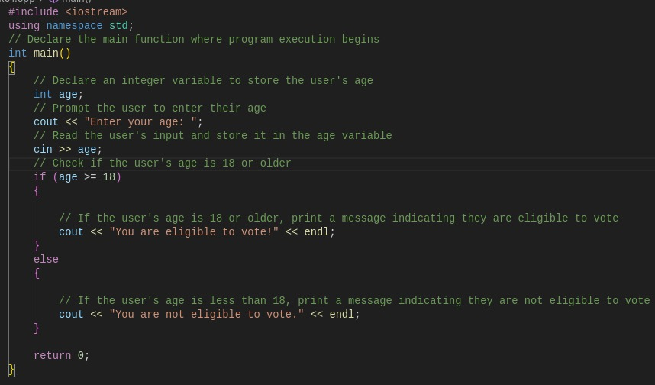**Code:**

**Output:**

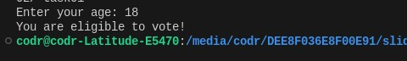

**Task # 02:**

A student will not be allowed to sit in the exam if his/her attendance is less than 75%.

Take the following input from user:

Number of classes held,

Number of classes attended.

And print:

Percentage of classes attended,

Student is allowed to sit in exam or not.

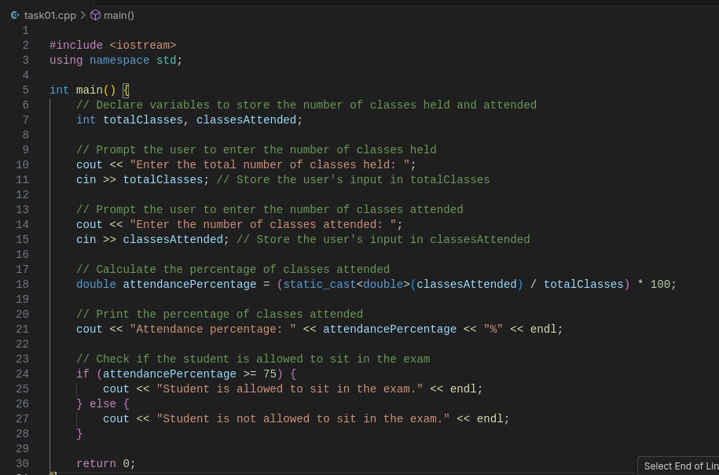**Code:**

**Output:**

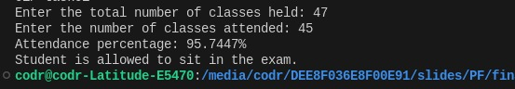

**Task # 03:**

Consider an integer value given as: int num = 5;

Display the square of the number given when the spacebar key on the keyboard will be pressed.

**Hint:** use getch().

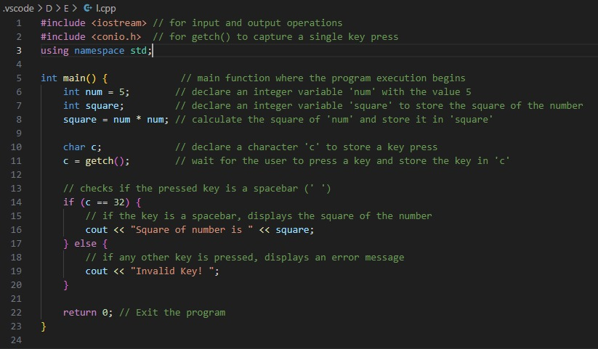**Code:**

**Output:**

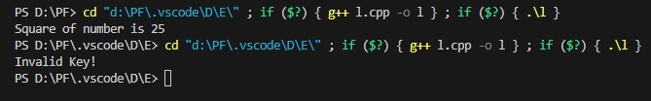

**Task # 04:**

Develop a C++ program that prompts the user to input two 2x2 arrays. The program should then perform both addition and subtraction of the arrays, storing the results in separate 2x2 arrays. Finally, it should display the results of these operations.

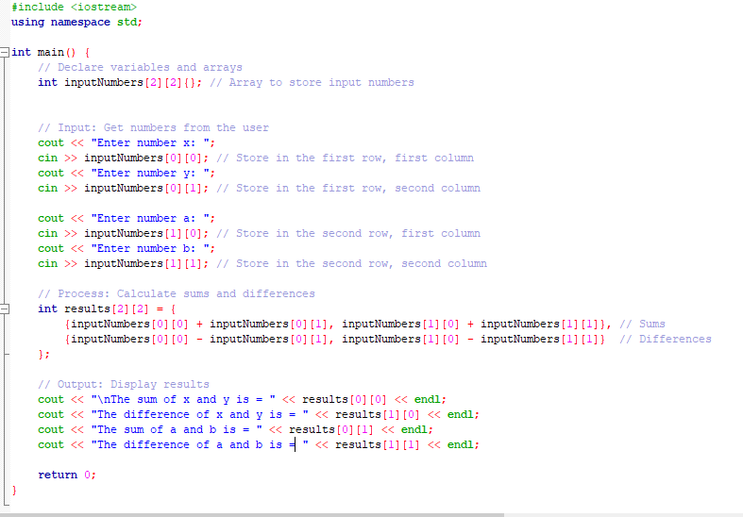**Code:**

**Output:**

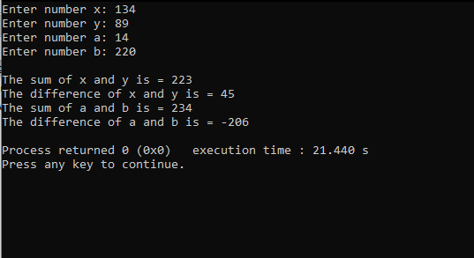

**Task # 05:**

Create a C++ program to generate a student's report card. Take inputs like student name, grades for different subjects (using arrays), and calculate the total marks and average. The program should contain a Class named Student for storing all variables and methods. The program should contain function like inputGrades(), calculateTotal(), calculateAverage() for the separate calculation. At the end, the program should display the result by catching data from a function named displayReportCard().

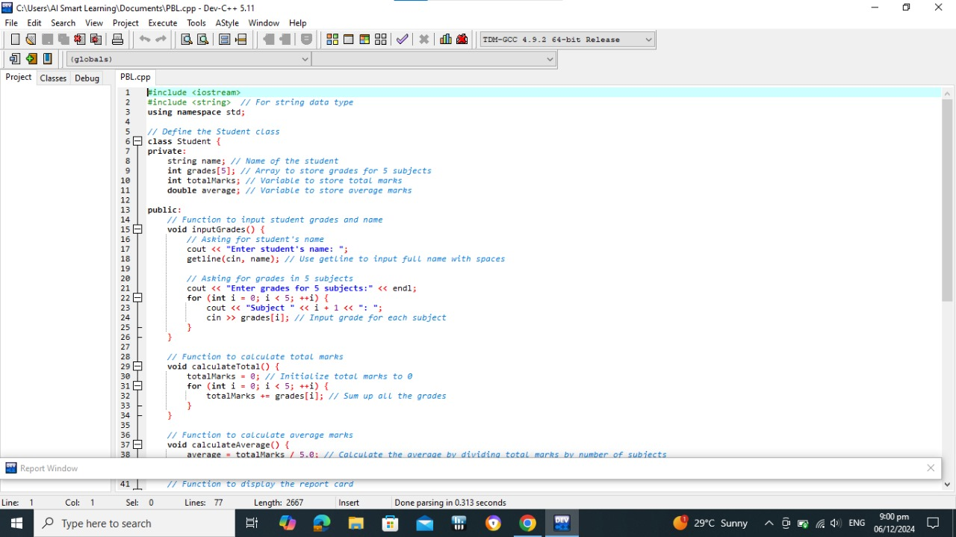**Code:**

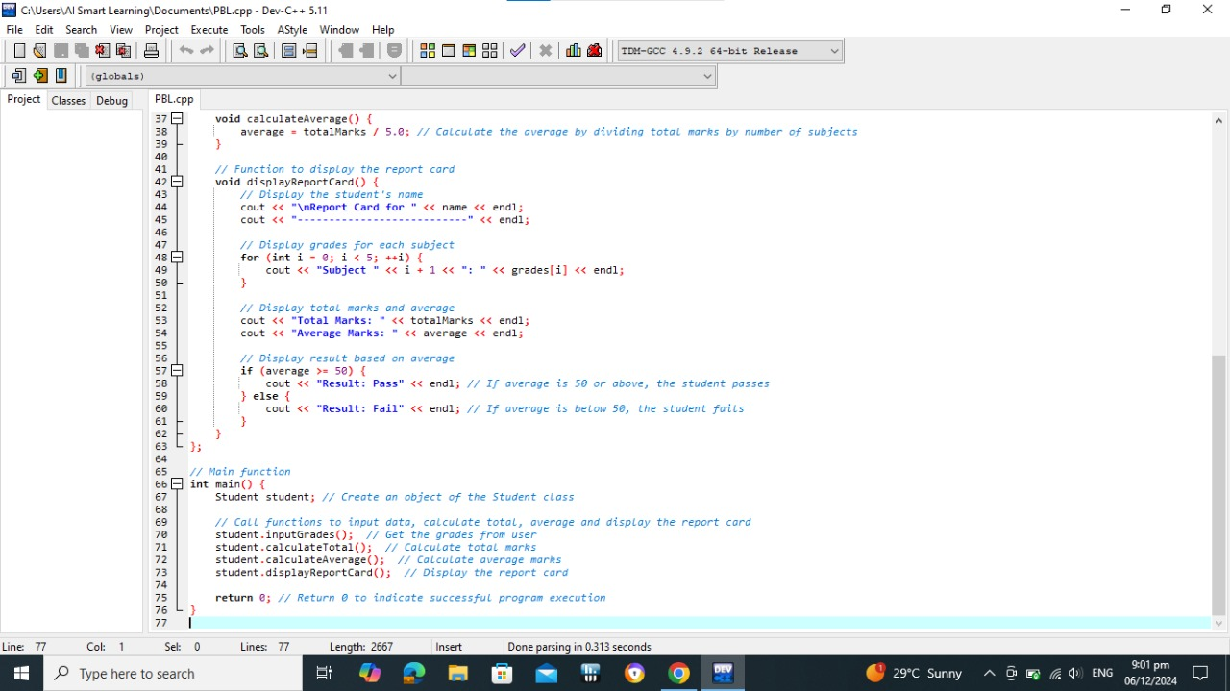**Output:**

